AI Use Declaration Form
Course: Introduction to Artificial Intelligence
Lab Title: Lab 3 - Neural Networks: Feedforward Networks and the Training Process
Student Name: __________Oluwademilade Subair_______________________________
Student ID: _____________58742028______________________________________
GitHub Repository Link:__https://github.com/jupiterbouncer/Subair_Oluwademilade_Lab3/__
Date Submitted: ___________28th July 2026________________________________

1. AI Use Summary
Question | Student Response
Did you use any AI tool for this lab? | Yes
Estimated percentage of the work influenced by AI | 9 %
Did you attach evidence of AI use where applicable? | Yes

2. Details of AI Use
Complete the table below for each AI tool used. Add more rows where necessary.
Name of AI Tool Used | Purpose for Using the Tool | Prompt or Instruction Given to the Tool | Part(s) of the Work Influenced by the Tool | How I Verified, Edited, or Improved the AI Output
Claude | Converting the mathematics done in Section 1.1 on paper to LaTeX | “how do I do the latex” | Part 1.1 | Built on the template provided
Claude | Debugging a value error | “keep getting a value error, anything I’m missing out on? {code ref}” | Part 1.2 | Re-ran code with reshaped x & y
Claude | Debugging an error when it came to loading models of different architectures | “{code ref}” | Part 2.4 | Re-formatted saving format for different models
Claude | Verifying parameter count | “got 1408 for the parameter count verify” | Part 2.1 | N/A

3. Attachment of AI Output Evidence
Where required, attach evidence of AI use. Tick all that apply. Add more rows where necessary.
Evidence Type | Attached? (Yes, No, N/A) | File Name
AI-generated draft | N/A
Prompt history | N/A
Screenshot of AI interaction | Yes | 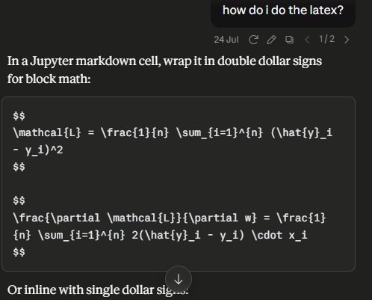  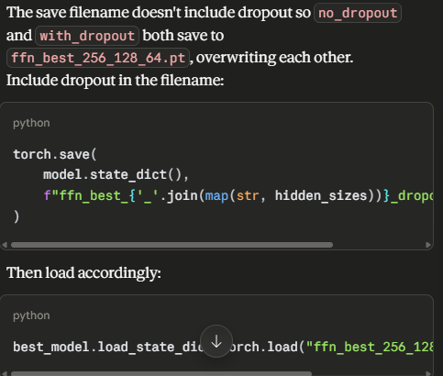  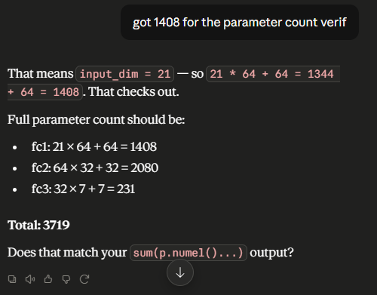
Exported AI conversation | N/A
AI-generated code snippet | Yes | Attached above
Revised version showing student input | N/A

4. Student Declaration
I declare that:
Declaration Statement | Response (Yes/No)
The submitted work is my own work. | Yes
Any use of AI tools has been clearly declared in this form. | Yes
The prompts, instructions, and AI-generated outputs have been disclosed where applicable. | Yes
I reviewed, tested, edited, and improved any AI-generated content before submission. | Yes
My AI usage does not exceed 25% of the entire work. | Yes
I understand that undeclared or excessive AI use may be treated as academic misconduct. | Yes

Student Signature: ___________________________________________
Date: ________________28th July 2026___________________________

